ONLINE JOB PLACEMENT
(Dream Job)

Submitted to: Miss MISBAH ANWER
Submitted by: Farhana Ghayas
Submission Title: Software Requirements Specification
Submission Date: 21-Feb-2015

Course: Database Management System
Class: MCS Final
Dept.: UBIT

Table of Contents
Contents
1. Introduction 2
2. The General Description 2
- Features of the Website 2
3. Specific Requirements 3
- Modules 3
✓ Recruiter’s Panel 3
✓ Job Seeker Panel 3
✓ Admin Panel 3
4. Supporting Information 4
- Software 4

1. Introduction
In today’s generation the search of a job is searched through internet. The candidate can input his/her requirement according to their needs and perform search operation to get their ideal job.

2. The General Description
Online Job Placement Website is aimed at computerizing the activities involved Job seeking and recruitments. The prime activities figured out in this process include find suitable company, etc.
The Online Job Placement Website provides all kinds of record keeping feature required in getting job and hiring employees.

Features of the Website
- Easy to operate and user friendly.
- Job alerts.
- Complete history of visitors at your websites.
- Role Based Security.
- Easy and Fast Search.
- Complete Admin Panel.

3. Specific Requirements

Modules
The Online Job Placement Website consists of
- Job Seeker Panel (Register/Unregister)
- Recruiter’s Panel
- Admin Panel

Recruiter’s Panel
- A Recruiter can Register himself and have to add his Company information.
- He or she can post job.
- The entire candidate that applies for his posted job can be seen by recruiter.
- A recruiter sees information of interested candidates and select candidates that are most suited for his posted job.
- When Recruiter select any candidate a message created automatically and send to the job seeker to inform him that his/her have been shortlisted and company going to contact that person soon through email or call for interview.

Job Seeker Panel
- Job seeker can see posted job having an option of apply for this job.
- He cannot apply for any job until unless that person is not register himself by creating account.
- After having account user can apply for the job, he/she must login first by entering his/her id and password.
- By Account details the job seeker panel appears, Job seeker can add his information; upload cv. and having an inbox in which all the notifications that he is selected for following applied job are listed.

Admin Panel
The Admin Panel deals with the maintenance of the website.

- Add, modify, and delete information on Website.
- Admin can create new roles and security policies.
- Manage users, have access to all the account’s information.
- He can deactivate suspicious accounts.

4. Supporting Information

Software
- Visual Studio .Net / ASP
- IIS server
- .Net Framework 4.5
- SQL Server 2012

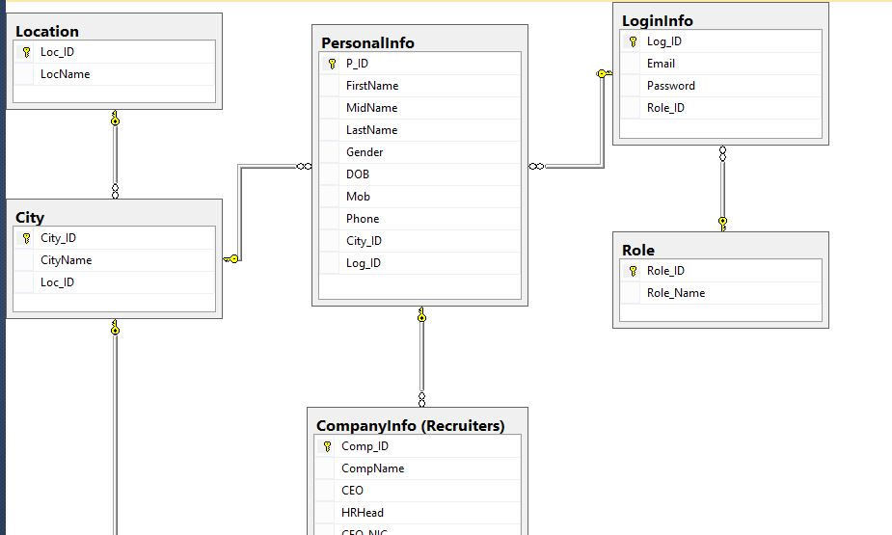
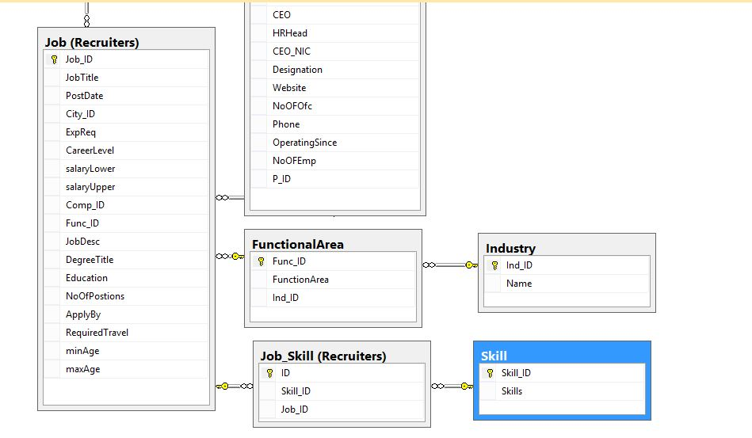
ERD

